Title of Manuscript (Capital Letter of Each Word; Font type: Calibri (body), Font size: 18, Align Centre)

Full Author Name ^{1,2}, Full Name Corresponding Author¹*, Full Author Name¹ (All authors name must be written in full name. Font type Calibri Font Size 10: Paragraph: align centre)

¹School of Technology Management and Logistics, Universiti Utara Malaysia, 06010 Sintok, Kedah, Malaysia
²School of Industrial Technology, Universiti Sains Malaysia, 11800 USM, Penang, Malaysia
(Please provides full institution/organization address. Font type Calibri Font Size 9: Paragraph: align centre)

*Corresponding author email: author2@gmail.com

LIST OF ALL AUTHORS AND EMAIL

Full Author Name | Email Address
Author 1 | Author1@gmail.com
Author 2 | Author2@gmail.com
Author 3 | Author3@gmail.com
Add more row if needed | Add more row if needed

ABSTRACT

The abstract should contain between 100 and 350 words. A concise and factual abstract is required. The abstract should state briefly the purpose of the research, the principal results and major conclusions. An abstract is often presented separately from the article, so it must be able to stand alone. Citation or references should be avoided in the abstract.

Keywords: Minimum three keywords; Use semicolon as separator

Received October x, 2023; Revised October xx, 2023; Accepted October xx, 2023
Doi: https:xxxxxxxxxxx
____________________________________________________________________________________________________________

1. INTRODUCTION

The first sentence should start here. [Format for first heading: Use a numbering system starting with 1; All uppercase; Calibri, 10 pt, bold, align left; single line spacing]. For example: Thermogravimetric analysis (TGA) is the most common technique used for kinetic analysis of the devolatilization process, and it provides the possibility of evaluating the mass loss of a sample with temperature and time (White et al., 2011).

Second paragraph starts here (single line spacing between paragraph). [Format for body text: No indentation; Calibri, 10 pt, justified alignment; 0 pt before and 0 pt after paragraph spacing; single line spacing].

Generally, in manuscript should have 1. Introduction (research background and literature review); 2. Methodology or Materials and Methods, 3. Results and Discussion; 4. Conclusion; Acknowledgement, References. You may add more if required.

2. METHODOLOGY

You need to write at least a paragraph under the first heading before using a subsection. You can use as many subheadings as you like, but you need to number them appropriately.

2.1 Sample Preparation

[Format for second heading: Use a numbering system starting with x.1; Capitalize Each Word; Calibri, 10 pt, bold, align left; 0 pt before and 0 pt after paragraph spacing; single line spacing].

2.1.1 Sample Testing

[Format for third heading: Use a numbering system starting with x.x.1; Capitalize Each Word; Calibri, 10 pt, bold, Italic, align left; 0 pt before and 0 pt after paragraph spacing; single line spacing].
You will continue to use the 2-column layout until you want to insert figures and/or tables. To change the layout from two-column to one-column, you will insert a Continuous Section Break [located under Page Layout], change the format to one column, and then insert your figure/table below the Section Break.

3. RESULTS AND DISCUSSION

All tables and figures must have a corresponding caption. Table should be placed at the center. The table caption must be placed above the table and the figure caption will be placed below the figure. Try to keep your whole table on the same page. If you must split your table, must sure that you include a table heading to the second half of the table too. The word for table in the body paragraph must be bold (example: Table 1)

All Figures must follow the standard of quality for publication. Authors must provide a high quality with high resolution Figure. Content in the Figure should be clear and readable. Each Figure must be discussed or mentioned in a body paragraph and bold (example Figure 1). The Figure must be placed under the paragraph that discussed about the Figure.

All equation that mentioned in body paragraph should be written as Eq. (1). Please use Microsoft Equation in order to present an equation. The font size of equation is 10. Each equation must be numbered.

Table 1: This is a Simple Example
Column 1 | Column 2 | Column 3
A | 1 | 5
B | 2 | 6
C | 3 | 7
D | 4 | 8

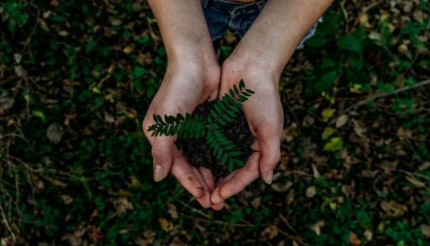  (a) | (b)
Figure 1: Figure Quality a) Clear b) Clear

4. CONCLUSION

Make sure that you end your paper with a Conclusion or Summary or Recommendations section.

REFERENCES

[Format for References: Calibri, 10 pt; 0 pt before and 0 pt after paragraph spacing; single line spacing; Use APA citation style. The addition of DOI (Digital Object Identifier) numbers is recommended but not essential.]

Grady, J. S., Her, M., Moreno, G., Perez, C., & Yelinek, J. (2019). Emotions in storybooks: A comparison of storybooks that represent ethnic and racial groups in the United States. Psychology of Popular Media Culture, 8(3), 207–217. https://doi.org/10.1037/ppm0000185
Duckworth, A. L., Quirk, A., Gallop, R., Hoyle, R. H., Kelly, D. R., & Matthews, M. D. (2019). Cognitive and noncognitive predictors of success. Proceedings of the National Academy of Sciences, USA, 116(47), 23499–23504. https://doi.org/10.1073/pnas.1910510116
Kabir, J. M. (2016). Factors influencing customer satisfaction at a fast-food hamburger chain: The relationship between customer satisfaction and customer loyalty (Publication No. 10169573) [Doctoral dissertation, Wilmington University]. ProQuest Dissertations & Theses Global.
Dillard, J. P. (2020). Currents in the study of persuasion. In M. B. Oliver, A. A. Raney, & J. Bryant (Eds.), Media effects: Advances in theory and research (4th ed., pp. 115–129). Routledge.
Schaefer, N. K., & Shapiro, B. (2019, September 6). New middle chapter in the story of human evolution. Science, 365(6457), 981–982. https://doi.org/10.1126/science.aay3550
National Cancer Institute. (2019). Taking time: Support for people with cancer (NIH Publication No. 18-2059). U.S. Department of Health and Human Services, National Institutes of Health. https://www.cancer.gov/publications/patient-education/takingtime.pdf

